A Virtual Tour Commemorating the Life & Legacy of Robert Smalls, Civil War Hero & African American Statesman
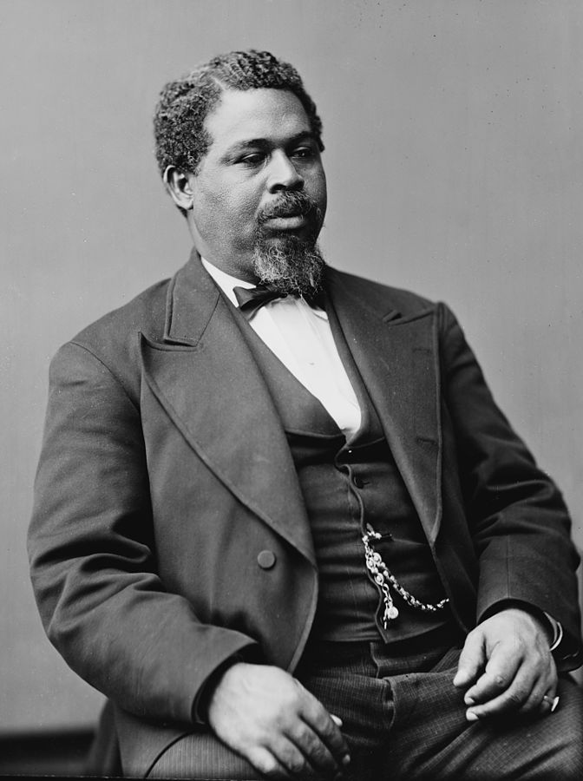
Robert Smalls: South Carolina Hall of Fame, Myrtle Beach, SC
Inducted 2010.
Robert Smalls was born a slave in Beaufort, S.C. in 1839. He was taken to Charleston, where he worked a variety of jobs and learned seafaring before becoming the pilot of a Confederate transport steamer, the Planter. Smalls taught himself to read and write, and was determined to free himself.
On the morning of May 13, 1862, while the ship's officers still slept, Smalls smuggled his wife and three children aboard the Planter. With his crew of 12 slaves, Smalls hoisted the Confederate flag and sailed past other Confederate ships and out to sea. Once beyond the range of the Confederate guns, he hoisted the flag of truce and delivered the Planter to the commander of the Union fleet. The ship was received as contraband, and Smalls and his black crew were welcomed as heroes. Later, President Lincoln received Smalls in Washington and rewarded him and his crew for their valor. He was given official command of the Planter and made a captain in the U.S. Navy.
After the war Smalls returned to South Carolina and served in the Senate from 1868 to 1870. In 1875 he was elected to the U.S. Congress where he fought for equal travel accommodations for black Americans and for civil and legal protection of children of mixed parentage.
After leaving Congress, Smalls was duty collector for the port of Beaufort. He retained his interest in the military and was a major general in the South Carolina militia. He died on Feb. 22, 1916.
Henry McKee/ Robert Smalls House, 511 Prince Street, Beaufort, SC
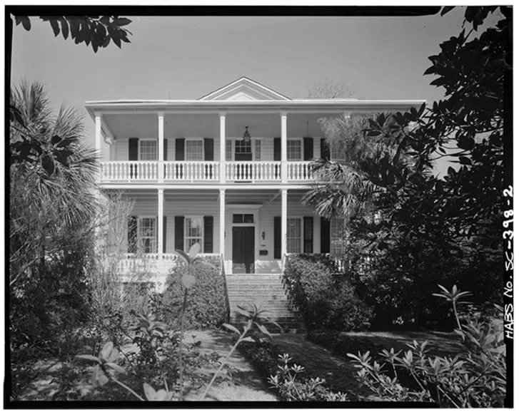
Originally constructed around 1810 by Smalls’ enslaver, Henry McKee, this building served as a setting for some of the most influential years of Robert Small’s life - from his time of enslavement to his service as a member of the United States House of Representatives, and as one of the most influential African American figures during the Reconstruction Era.
Smalls was born on the property on April 5, 1839 to Lydia Polite, who was also enslaved by McKee. For the first twelve years of his life, Smalls bore witness to the horrors of slavery on and around this property, as well as on land owned by McKee on Lady's Island. In 1851, Smalls was hired out and sent to work in Charleston, where, in 1856, he married Hannah Jones, with whom he had two children. Before the start of the Civil War, Smalls worked aboard a transport boat known as "The Planter." It was on this ship that he escaped Confederate forces in Charleston Harbor and self-emancipated himself and his family, as well as several other enslaved crewmen, on May 13, 1862. For this act he received a Congressional reward of $1,500, which he used to purchase the home where he and his mother were once enslaved.
After white residents fled Beaufort County in 1861, and US troops occupied the region, much of the property abandoned went up for auction due to unpaid taxes. Among the properties that were sold during early Reconstruction was the former McKee home, which Smalls purchased for $605 in January 1864. He lived in this house with his family for the rest of his life. When he died in 1915, the home was inherited by his descendants. His daughter, Elizabeth Smalls Bampfield, noted in a 1959 interview that the home remained in the family's hands until the early 1950s. In 1974, the house was designated a National Historic Landmark

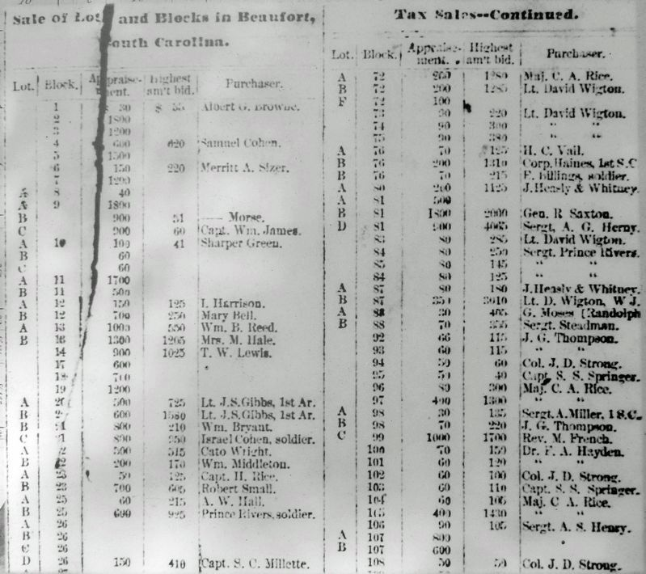
The Free South, January 1864
This January 1864 issue of The Free South contains a listing of who purchased lots on the corresponding tax map of downtown Beaufort. Robert Smalls purchased Block 23, Lot B — today 511 Prince Street. Owning property was a goal for many formerly enslaved people during Reconstruction.
Charleston Harbor, 40 East Bay Street
The Seizure of the Planter
Early on May 13, 1862, Robert Smalls, an enslaved harbor pilot aboard the Planter, seized the 149-ft. Confederate transport from a wharf just east of here. He and six enslaved crewmen took the vessel before dawn when its captain, pilot, and engineer were ashore. Smalls guided the ship through the channel, past Fort Sumter, and out to sea, delivering it to the Federal fleet which was blockading the harbor. Northern and Southern newspapers called this feat "bold" and "daring." Smalls and his crew, a crewman on another ship, and eight other enslaved persons including Smalls' wife, Hanna, and three children, won their freedom by it. Smalls (1839-1915) was appointed captain of the Planter by a U.S. Army contract in 1853. A native of Beaufort, he was later a state legislator and then a five-term U.S. Congressman.
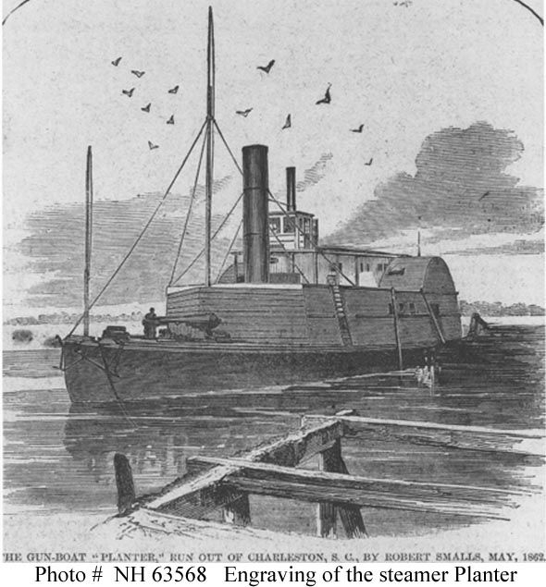
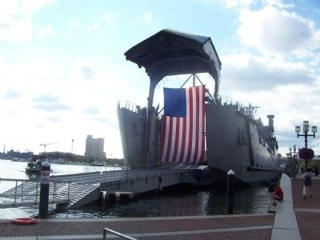
U.S. Army Vessel MG Robert Smalls (LSV-8) with bow ramp extended
Named in honor of Robert Smalls (Civil War hero, rights activist, Congressional Representative, and major general in the South Carolina Militia), the ship is the U.S. Army's largest water vessel, commissioned 15 September 2007 in Baltimore, MD.
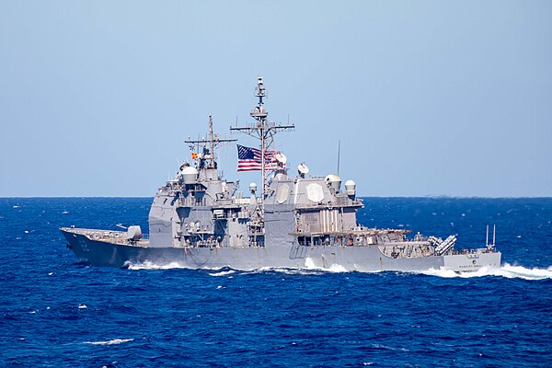
USS Robert Smalls
On March 1, 2023, the Navy renamed USS Chancellorsville to USS Robert Smalls
St. Helena Island: The Port Royal Experiment & Penn School
The Port Royal Experiment
In 1860, South Carolina became the first state (of eleven) to declare itself independent from the United States, launching the U.S. Civil War. The first shots were fired on nearby Fort Sumter in April 1861. South Carolina was an immediate target of the Union’s armed forces. The Sea Islands, including St. Helena, were occupied by Union forces early in that long conflict.
Because of that occupation, as early as November 1861, the coastal areas of South Carolina became home to an experiment in how to reorganize a society and economy built on enslaved labor, into a free one. By mid-1862, the Port Royal Experiment established schools and hospitals, and enabled freed people to buy former plantation land at low prices. African Americans in the Sea Islands kept the land productive and built their own financial independence, far earlier than anywhere else in the country—and before the more restrictive Reconstruction policies took hold.
The Penn School
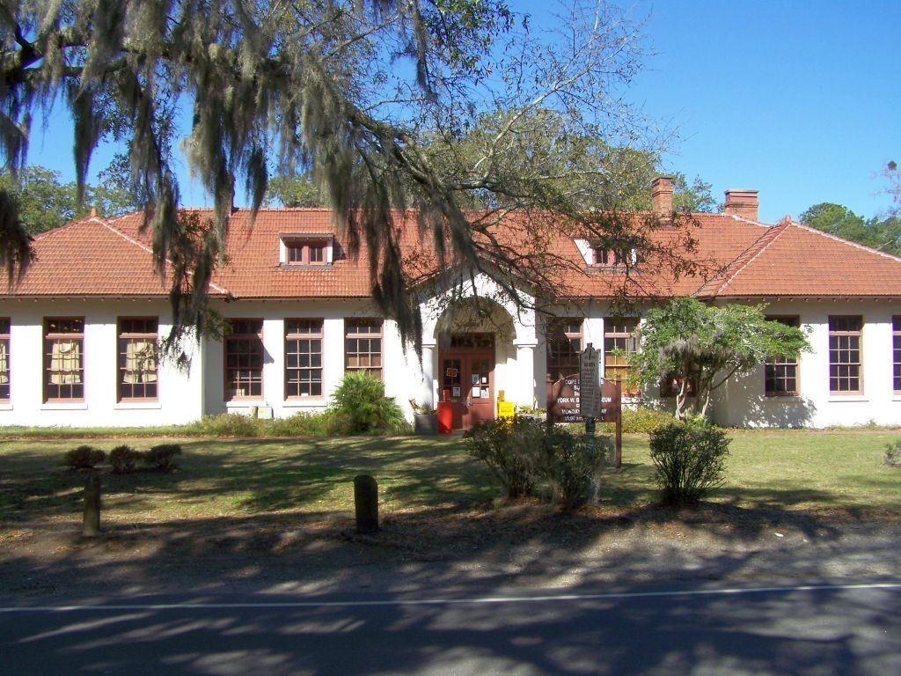
The Penn School was one shining example of the Port Royal Experiment.
After Union occupation of the Sea Islands in 1861, two northerners, Laura Towne and Ellen Murray, came to assist the freed blacks of the area establishing Penn School here in 1862. The earliest known black teacher was Charlotte Forten, who traveled all the way from Massachusetts to help her people.
One of the first schools for blacks in the South, Penn School, was reorganized as Penn Normal, Industrial and Agricultural School in 1901. As a result of this change, incorporating principals of education found at both Tuskegee and Hampton Institutes, Penn became an international model. Its program was removed to the Beaufort County school system in 1948.
Robert Smalls was an early supporter of the Penn School, and his daughter attended the Penn School.
Brick Baptist Church, first site of the Penn School
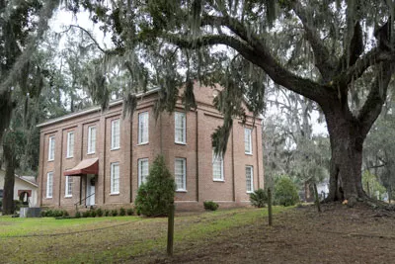
Enslaved people built the Brick Baptist Church on St. Helena Island in 1855 as a place of worship for white planters, several of whom are buried in the small cemetery next to the sanctuary. Fingerprints of the enslaved who made the bricks can still be seen in some of the walls. After the Union Army liberated the Sea Islands, the church became a haven for enslaved people, and, in 1862, Laura Towne and Ellen Murray established what became the Penn School in this sanctuary.
First African Baptist Church, 601 New Street, Beaufort, SC
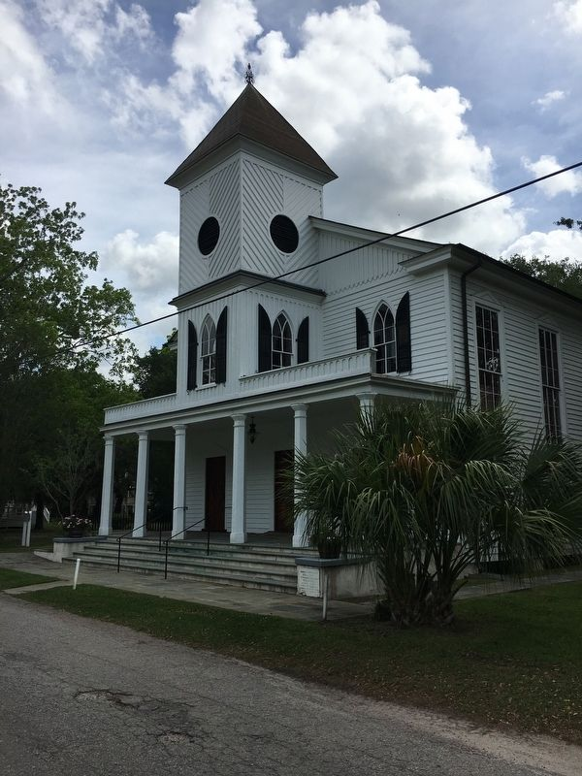
First African Baptist Church was built in the Gothic Revival style circa 1861 by the Baptist Church of Beaufort for its black members who far outnumbered the white congregants. The black congregation took over the building in 1863. Robert Smalls helped found the congregation and attended services. Needing funds to repair Civil War damage in their own church, the Baptist Church of Beaufort sold the structure to the congregation’s deacons for $300 in 1868, at a considerable discount. The building “was enlarged and beautified” before 1873. Smalls family weddings and funerals were held here.
This church, founded in 1865, grew out of an antebellum praise house for black members of the Baptist Church of Beaufort. Praise houses are one room church houses in the Sea Islands that provide places of worship, social events, and educational classrooms for African Americans.
During the Civil War, after the Federal occupation of the town, it hosted a school for freedmen. Rev. Arthur Waddell (1821-1895), its founding pastor, had come to S.C. from Savannah, Ga. In 1867 Rev. Waddell and two black ministers from Savannah formally organized this church.
In 1885 the congregation, with more than 900 members, built this "handsome and commodious" Carpenter Gothic church. Rev. Waddell continued to serve this church until he retired in 1894. At his death in 1895 First African Baptist was described as "one of the most aristocratic colored churches."
Robert Smalls (1839-1915), Civil War hero, state legislator, and U.S. Congressman, was its most prominent member.
Robert Smalls and others helped to purchase the church from the larger Baptist Church of Beaufort. In addition, Smalls financially supported the pastor of First African by donating weekly 25 cents. On February 5, 1905, Robert Smalls was baptized at First African. In 1915, Smalls's funeral was held at First African Baptist Church and his procession and burial was at Tabernacle Baptist Church located on Craven Street. Throughout his life, Smalls knew the importance and role of black churches in African American communities and continued to support the community spiritually, financially, and politically through church affiliation.
South Carolina State House, 1100 Gervais Street, Columbia, SC
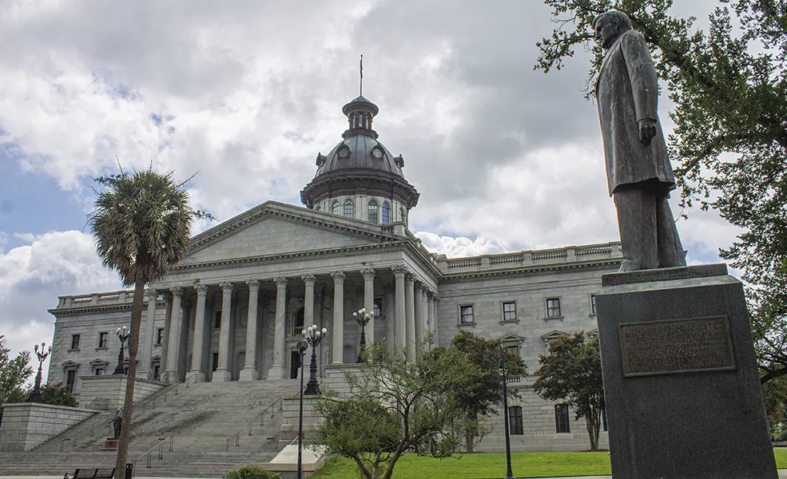
Construction on the South Carolina State House began in 1855 with between 375 and 500 men, about 60% of whom were enslaved African Americans, and many others Irish immigrants, cutting and hauling stones from a quarry near the Congaree River. Their efforts ceased in 1861 with the start of the Civil War.
When Union forces converged on Columbia in February 1865, the unfinished State House was an easy target for Union cannoneers who bombarded it from the west bank of the Congaree River. Today, six bronze stars mark places where shells from their 20-pound Parrott guns damaged the granite walls. The intense fire that destroyed the neighboring wooden State House also cracked the basement cornice and quoins in the southwestern corner of the new State House.
In 1869, a temporary roof allowed the government – the only African American majority state legislature in the history of the United States – to finally occupy the building for the first time. More than 80 African Americans served as legislators from 1868 through 1877. After Reconstruction ended, black people were systematically eliminated from government and businesses throughout the South, especially in South Carolina. In 1970, Herbert Fielding, James Felder, and I.S. Leevy Johnson won election to the S.C. House of Representatives, the first African Americans to serve in the State House since 1902.
In June 1864, Robert Smalls had been part of a delegation of free blacks to attend the National Republican Party Convention. As a civilian, Robert Smalls went to Columbia as a delegate to the state Constitutional Convention of 1866, advocating mandatory public education for children. In 1867, Richard H. Gleaves, Smalls, and thirty-six other black local leaders formed the first chapter of the Republican Party in South Carolina. From 1868 to 1870, he served in the South Carolina House of Representatives as a Republican and was elected to the state Senate for an additional four years. While there, he supported internal improvement and industrial development throughout the state, but most particularly for Beaufort County. His tenure was not without difficulties as he was tried, convicted and eventually pardoned for accepting a bribe during the tumultuous Reconstruction years.
The first of Smalls’ five terms in the United States Congress began in 1875. Although he lost his seat from 1880 to 1881, he regained his seat in 1881, after contesting the results. Robert Smalls served in the House of Representatives until 1887, in the 44th, 45th, 47th, 48th, and 49th Congresses. His most vocal opponent was William Elliott, of a Beaufort planter family. The two men disputed the congressional seat as each took his cause for overturning election irregularities to the 50th U. S. House Committee on Elections. Smalls never returned to a congressional seat.
Smalls backed progressive causes, like equal travel accommodations for African Americans, redistribution of land confiscated by the Federal government and full legal protection for children of mixed race. He sought money to restore the Beaufort Library whose collection had been confiscated during the Civil War and later destroyed in a fire. Smalls also foresaw the need to put up telegraph lines in South Carolina. While Smalls was progressive in outlook, the political milieu in which he lived was not. African American lawmakers struggled even to obtain basic rights for blacks.
As delegate to the South Carolina Constitutional Convention of 1895, Smalls witnessed the enactment of Jim Crow legislation that would greatly reduce the legal rights of black South Carolinians for decades to come. In his Convention speech, Robert Smalls objected that the issue of the bribery conviction had been revived by his opponents “to inflame the passions of delegates against Republicans against Republicans and force them to vote for this most infamous Suffrage Bill, which seeks to take away the right to vote from two-thirds of the qualified voters of the State.” He said, “It was the brawny arm of the Negro which cared for you in your cradle, made your harvest, protected you in your homes, and yet he is the man you propose to rob of his suffrage.”
Concluding his now-famous speech, Smalls said that all African Americans needed “is an equal chance in the battle of life. I am proud of them, and by their acts toward me, I know that they are proud of me, for they have at all times honored me with their vote. I stand here the equal of any man. I started out the war with the Confederates; they threatened to punish me and I left them. I went to the Union army. I fought in seventeen battles to make glorious and perpetuate the flag that some of you trampled under your feet.” Excerpts from his statement to the Convention appear on the base of his bust at Tabernacle Baptist Church. Smalls refused to sign the South Carolina Constitution of 1895.
Proposed Robert Smalls Monument, South Carolina State House Grounds, Columbia, SC
CONCURRENT RESOLUTION TO ALLOW FOR THE ERECTING OF A MONUMENT TO ROBERT SMALLS ON THE STATE HOUSE GROUNDS.
Whereas, the members of the General Assembly propose a monument of enduring historical significance to Robert Smalls, an escaped slave who became a Civil War hero and a legislator in the South Carolina General Assembly and served five terms in the United States House of Representatives; and
Whereas, Robert Smalls was born a slave on April 5, 1839, in Beaufort, South Carolina. He was the son of Lydia Polite but owned by John McKee; and
Whereas, during the Civil War, Mr. Smalls, illiterate and twenty-three years old, escaped by commandeering the Confederate ship, the Planter, on which he worked, delivering its black passengers from slavery to freedom through a gauntlet of gunboats and forts. Thereafter, he served the Union Army as a civilian boat pilot with distinction in numerous engagements, acted as a spokesperson for African Americans, and was made the first Black captain of an Army vessel for his valor; and
Whereas, Mr. Smalls served in the South Carolina House of Representatives, the South Carolina Senate, and the United States House of Representatives, enduring violent elections to achieve internal improvements for coastal South Carolina and to fight for his Black constituents in the face of growing disenfranchisement; and
Whereas, Mr. Smalls spoke openly in defense of his race and his party. Even with the rise of Jim Crow laws, Mr. Smalls stood firm as an unyielding advocate for the political rights of African Americans; and
Whereas, he was one of the first South Carolinians to advocate successfully for compulsory education; and
Whereas, Mr. Smalls played a critical role in bridging relations between the Black and White communities during and after Reconstruction; and
Whereas, he was the founder of the Enterprise Railroad Company of Charleston; and
Whereas, Mr. Smalls also served as brigadier general of the South Carolina Militia; opened a store for freedmen and a school for black children; published a newspaper, the Beaufort Southern Standard; and served as the U.S. Customs collector at the port of Beaufort; and
Whereas, he promoted the establishment of the US Naval Station at Port Royal and the purchase of Parris Island; and
Whereas, in 2007, the US Army named a ship after an African American for the first time, the support vessel Maj. Gen. Robert Smalls; and
Whereas, Mr. Smalls married Hannah Jones and, upon her death, remarried Annie Wigg. He had four children: Elizabeth, Sarah, Robert, Jr., and William Robert; and
Whereas, Mr. Smalls died in Beaufort on February 22, 1915, in the same house behind which he had been born and served as a slave, and later came to purchase; and
Whereas, a monument to honor Robert Smalls would represent the remarkable contributions, achievements, and accomplishments of this forgotten son of South Carolina and would serve as an overdue tribute to the many slaves who sacrificed alongside him. Now, therefore,
Be it resolved by the House of Representatives, the Senate concurring:
That the members of the General Assembly, by this resolution, and notwithstanding another provision of law, specifically and solely allow for the erecting of a monument to Robert Smalls on the State House grounds.
Former “William Fuller House” (razed), corner of Carteret and Washington Streets, Beaufort, SC
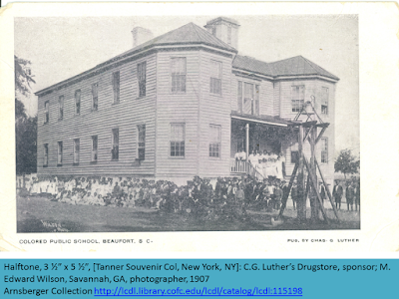
This site is significant as a marker of Robert Smalls’ commitment to establishing educational opportunities for African Americans during the Reconstruction period.
Colonel William Fuller built a house on these grounds in 1829. The Beaufort School Board of Education purchased the property in 1867 to open a public school for blacks. The deed had a proviso that the property always be used by citizens of Beaufort for school purposes. The board was mostly African American and consisted of Robert Smalls, Jonathan J. Wright, William J. Whipper, Richard H. Gleaves, London S. Langley, Walter Fuller, Isaac Simmons, Prince Rivers, R.F. Bythewood, Rev. Arthur Waddell, J.J. Cohen, George Waddell, and J.C. Rivers. In 1925 the Board of Education decided to raze the deteriorated black school and build a new school for black students to be called Robert Smalls High School at another site. The property is part of the University of South Carolina Historic Beaufort Campus complex today.
Robert Smalls Burial Site & Memorial, Tabernacle Baptist Churchyard, 911 Craven Street
A bust of Robert Smalls sculpted by Marion Talmage Etheredge sits next to Tabernacle Church. Although a founding member of First African Baptist Church, Smalls was interred between his two wives, Hannah Jones (1826-1883) and Annie Elizabeth Wigg (1856-1895) in this churchyard. The monument is inscribed with an excerpt from his speech contesting the SC Constitution of 1895 in which black citizens were stripped of many of the rights they had under Reconstruction: “My race needs no special defense, for the past history of them in this country proves them to be the equal of any people anywhere. All they need is an equal chance in the battle of life.” (1895)
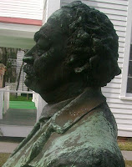
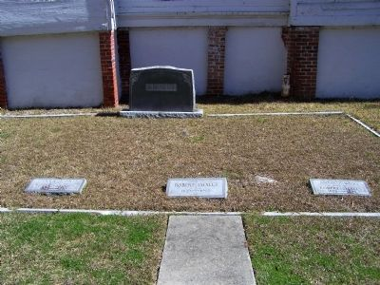
Born a slave in 1839, Robert Smalls lived to serve as a Congressman of the United States. In 1862 he commandeered and delivered to Union forces the Confederate gunboat Planter, on which he was a crewman. His career as a freedman included service as a delegate to the 1868 and 1895 State Constitutional Conventions, election to the SC House and Senate and nine years in Congress. He died in 1915 and is buried here.
Robert Smalls Memorial
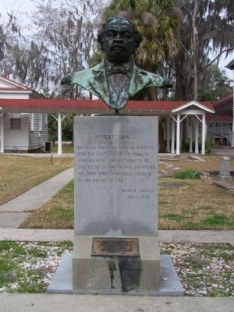
" My race needs no special defense, for the past history of them in this country proves them to be the equal of any people anywhere. All they need is an equal chance in the battle of life." Robert Smalls. Nov. 1, 1895
Tabernacle Church was formed by black members of Beaufort Baptist Church after other members evacuated the area because of Federal occupation in 1861. The church's lecture room was used for services during the war. In 1867 the black congregation bought this property from the Beaufort Baptist Church. Its present building was dedicated in 1894. Many new churches have grown from the Tabernacle.
SOURCES:
http://www.theofficialschalloffame.com/directlink.html?id=76
https://beaufortdistrictcollectionconnections.blogspot.com/2017/06/heritage-walking-tour-robert-smalls.html
https://www.hmdb.org/m.asp?m=20144
https://www.hmdb.org/m.asp?m=62069
https://www.nps.gov/places/the-robert-smalls-house.htm
https://www.penncenter.com/history-timeline
https://www.nps.gov/reer/planyourvisit/brick-baptist-church.htm
https://www.historiccolumbia.org/tour-locations/1200-gervais-street-3
https://www.scstatehouse.gov/sess125_2023-2024/bills/4173.htm
https://bdcbcl.wordpress.com/2018/12/20/robert-smalls-war-hero-public-servant-and-a-man-of-mark-1839-1915/

